**Name:RISSHITH BS**

**192210021**

**EXP 13:Create a Virtual Hard Disk and allocate the storage using VM ware Workstation.**

**Step 1: Create**

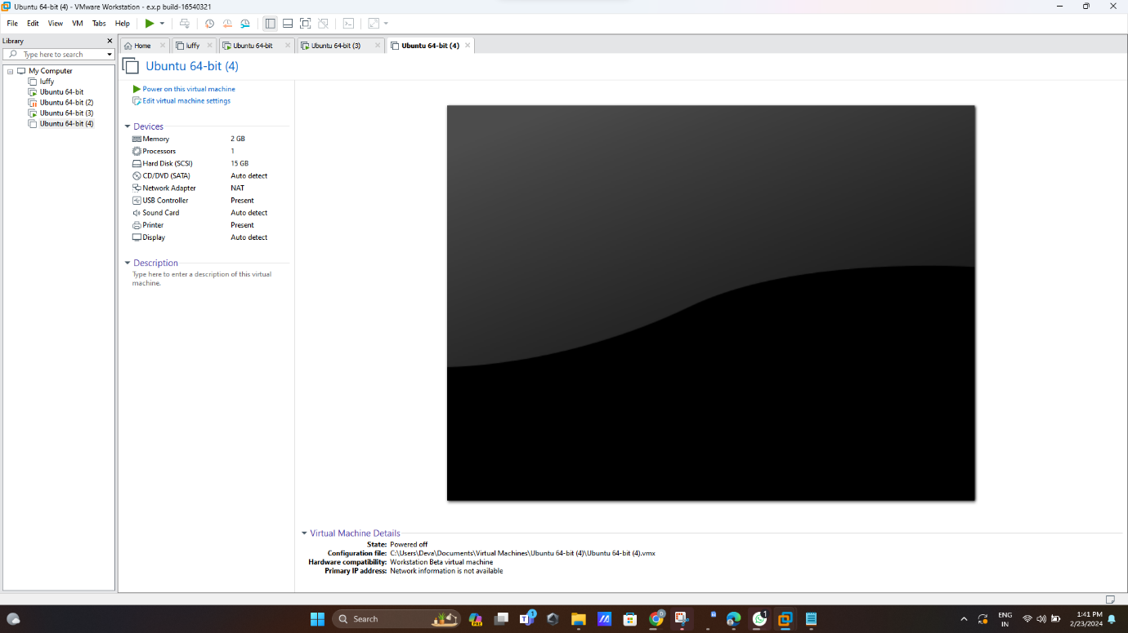

**Step 2: click add option**

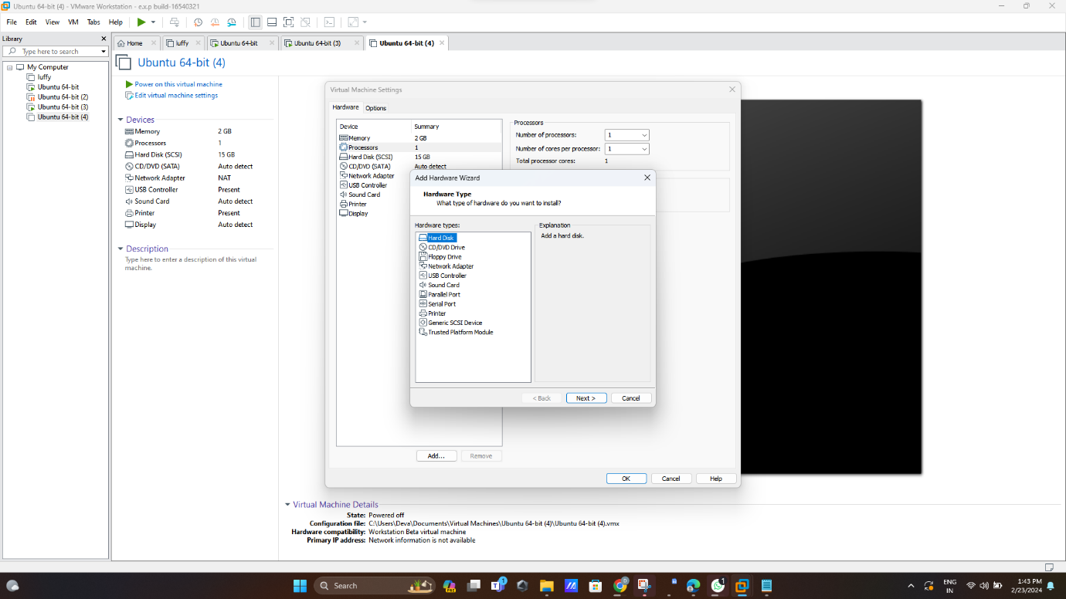

**Step 3:create new virtual disk**

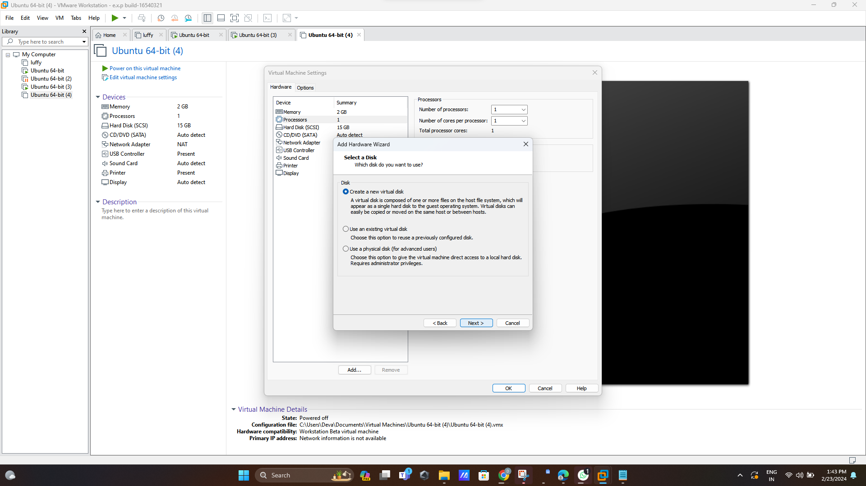

**Step 4:store virtual disk in single file**

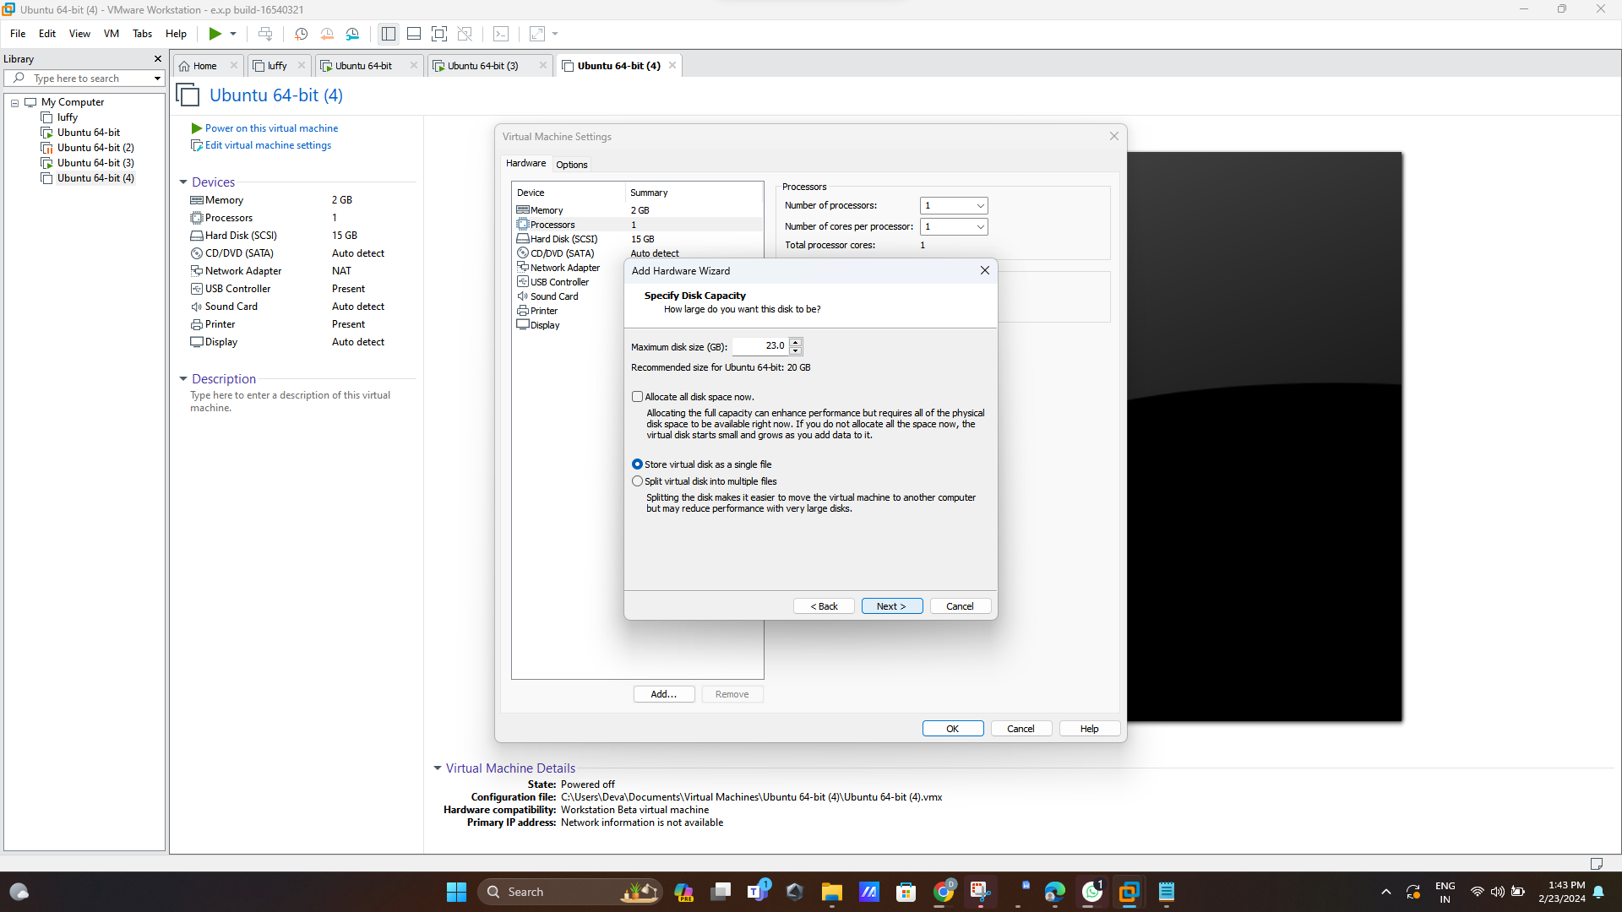

**Step 5:name the new hard disk**

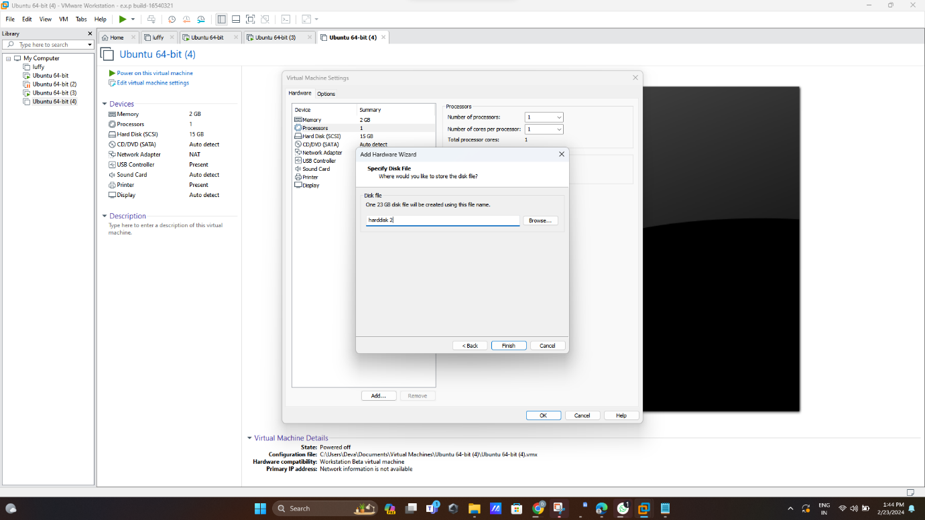

**Step 6:new hard disk create**

